Database:MSB_SANDBOX
Schema:SANDBOX_TASNIA_SANTA
Role:MSB_SANDBOX_ROLE
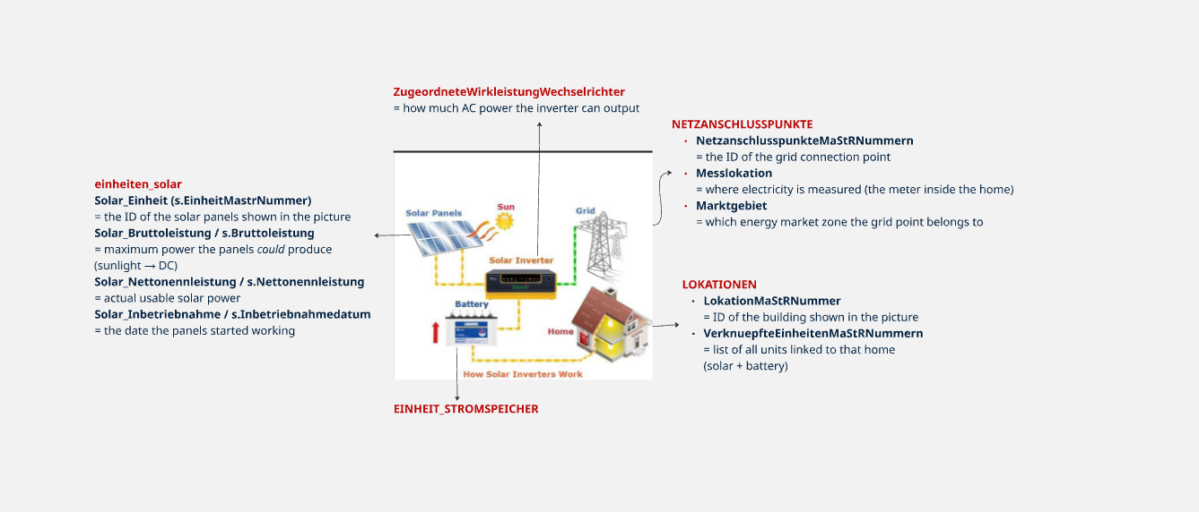
Customer METERINGCODE (MeLo)
↓
MaStR Messlokation (MeLo)
↓
Grid Connection (SAN)
↓
Location (SEL)
↓
Solar & Storage Units (SEE)

2.1 new_EinheitenSolar
Solar Generation Units (SEE = Stromerzeugungseinheit)
This table contains all PV (solar) units registered in MaStR.
Each row = one solar installation.
Columns explained:
- EINHEITMASTRNUMMER → Unique ID of the solar unit (SEE…)
- LOKATIONMASTRNUMMER → The location (SEL…) where the unit is installed
- POSTLEITZAHL
- ORT
- REGISTRIERUNGSDATUM → Date the unit was registered in MaStR
- INBETRIEBNAHMEDATUM → Date the PV plant started operating
- BRUTTOLEISTUNG → Nominal solar power (kWp)
- NETTONENNLEISTUNG → Actual active power (kW).. the maximum AC power the system is allowed to output,
- ZUGEORDNETEWIRKLEISTUNGWECHSELRICHTER → Inverter output (kW)
- SPEICHERAMGLEICHENORT → Whether a battery is at the same location
- NAMESTROMERZEUGUNGSEINHEIT → Name of the solar unit (e.g. "Hausdach links")
This table represents all solar systems tied to each SEL.
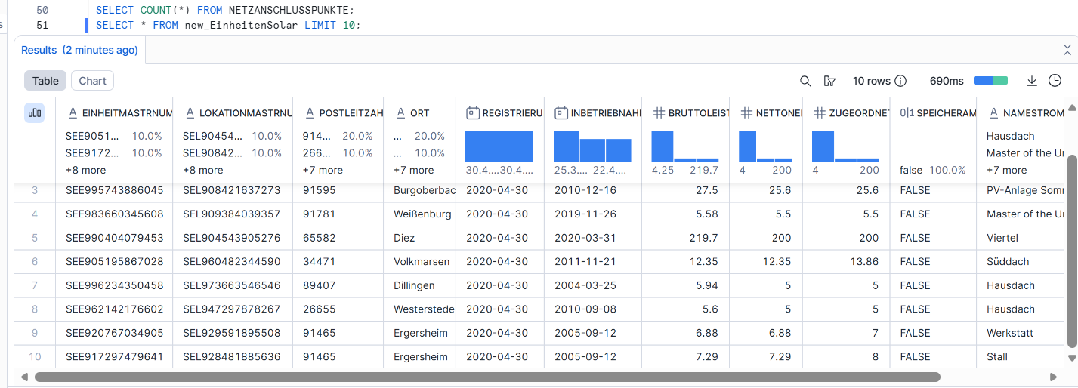
2.2 new_EinheitenStromSpeicher
Storage Units (Batteries, Home Storage)
This table contains all storage (battery) units from MaStR.
Columns explained:
- EINHEITMASTRNUMMER → ID of the storage unit (SEE…)
- LOKATIONMASTRNUMMER → Location ID (SEL…)
- POSTLEITZAHL
- ORT
- REGISTRIERUNGSDATUM
- INBETRIEBNAHMEDATUM
- BRUTTOLEISTUNG
- NETTONENNLEISTUNG
- ZUGEORDNETEWIRKLEISTUNGWECHSELRICHTER
- EEGMASTRNUMMER → EEG registration number (ONLY for batteries)
- NAMESTROMERZEUGUNGSEINHEIT
This table represents all battery systems associated with locations.
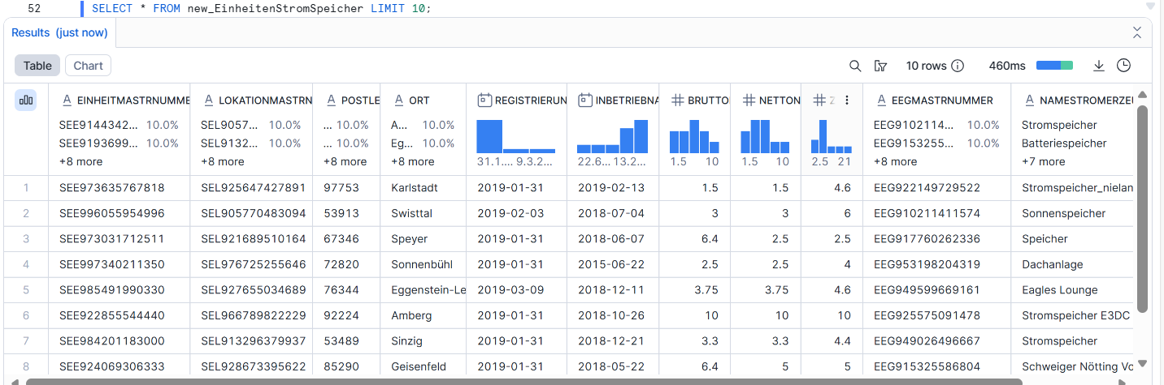
2.3 LOKATIONEN
Locations (SEL = Standort)
This table represents physical installation locations.
A location (SEL) can contain:
- multiple solar units
- multiple batteries
- one or several grid connection points (SAN)
Columns explained:
- MastrNummer → Location ID (SEL…)
- VerknuepfteEinheitenMaStRNummern → Comma-separated list of all SEE at that SEL
- NetzanschlusspunkteMaStRNummern → Comma-separated list of all SAN at that SEL
Think of SEL as the house or site where all units exist.
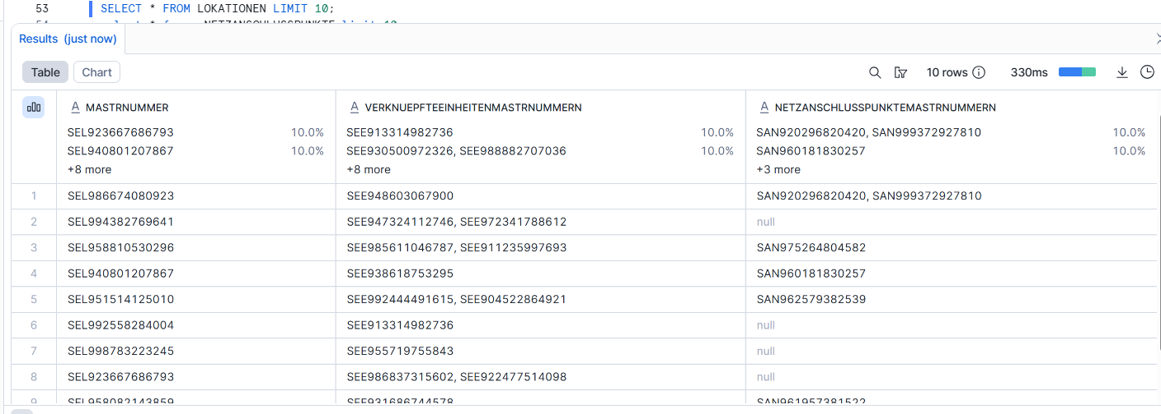
2.4 NETZANSCHLUSSPUNKTE
Grid Connection Points (SAN = Netzanschlusspunkt)
This table contains each grid connection point in MaStR.
Columns explained:
- NetzanschlusspunktMastrNummer → Grid connection ID (SAN…)
- LokationMaStRNummer → SEL this grid connection belongs to
- Messlokation → MeLo (metering point identifier)
- Marktgebiet → Market region area code
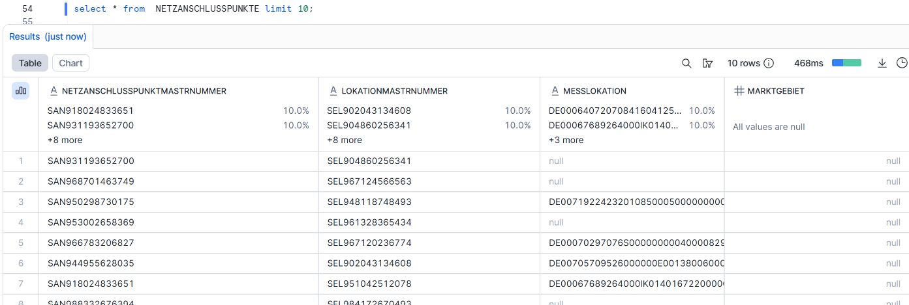
The MeLo (Messlokation) is the Zählpunktkennzeichnung,
the unique identifier used for matching customer ↔ MaStR.

- EINHEITMASTRNUMMER (VARCHAR)
- LOKATIONMASTRNUMMER (VARCHAR)
- POSTLEITZAHL
- ORT
- REGISTRIERUNGSDATUM (DATE)
- INBETRIEBNAHMEDATUM (DATE)
- BRUTTOLEISTUNG (FLOAT)
- NETTONENNLEISTUNG (FLOAT)
- ZUGEORDNETEWIRKLEISTUNGWECHSELRICHTER (FLOAT)
- EEGMASTRNUMMER (VARCHAR)
- NAMESTROMERZEUGUNGSEINHEIT (VARCHAR)
3. Customer Table (External Source)
Source:MSB_SANDBOX.EXPOSED.MD_CUSTOMER_REGISTER
This table contains Enpal’s customer master data.
It is the external dataset we want to connect to the MaStR registry.
Key Fields Used in Matching
- METERINGCODE
→ This is the MeLo for the customer.
→ A MeLo (Messlokation) is the official metering point ID (Zählpunktkennzeichnung).
→ It always starts with “DE00…” and matches exactly the MaStR field Messlokation.
→ This is the only correct join key between Enpal customers and MaStR grid connections.
- ABN_PLZ, ABN_ORT, ABN_STRASSE, ABN_HAUSNR
→ Installation address of the customer
→ Helpful for quality checks, secondary matching, or debugging.
- Salesforce Customer ID / Salesforce Account ID
→ CRM identifiers for reporting and linking to internal systems.
- GCID (Global Customer Identifier)
→ Internal Enpal customer identifier.
Many additional columns exist (PV package, contract timestamps, SEPA info).
These are not needed for MaStR matching but are preserved for final reporting.
4. Step-by-Step Pipeline
This section describes the three final tables and how they transform the raw MaStR data into a dataset that can be matched against Enpal customers.
We build these tables in three stages:
- Flatten MaStR → MASTER_MASTR_FIXED
- Aggregate by location → LOCATION_SUMMARY_FIXED
- Match with customer table → CUSTOMER_MATCH_FIXED
4.SEL_MELO_MAP
Mapping Location → Grid Connection → Metering Point
Purpose
The MaStR stores metering points (MeLo), grid connections (SAN), and installation locations (SEL) in separate tables.
To correctly link any PV or storage unit (SEE) to a customer, we must first create a clean mapping between:
- SEL (Standort / installation location)
- SAN (Netzanschlusspunkt / grid connection point)
- MeLo (Messlokation / metering point)
The table SEL_MELO_MAP creates this unified link.
What SEL_MELO_MAP contains
For every installation in MaStR, it provides:
- SEL – Location (MastrNummer of the installation site)
- SAN – Grid connection point ID
- MeLo – Metering point (Messlokation)
This table ensures that every installation location can be connected to the correct metering point, which is the ONLY key that can be matched to Enpal CRM customers.

4.1 MASTER_MASTR_FIXED
A fully flattened MaStR dataset
Purpose
This table combines four different MaStR concepts:
- SEE (solar unit)
- SEE (storage unit)
- SEL (location)
- SAN (grid connection)
- MeLo (metering point)
into a single row.
It becomes the “base table” for all further analysis. This table is the technical foundation for aggregating installations and linking them to Enpal customers.
What MASTER_MASTR_FIXED contains
match based SEL (melo) + on einheitenname from SEE, and then add everything at same SEL to customer
For each solar/storage unit, we include:
- Solar unit details (kWp, commissioning date, unit name)
- Storage unit details (battery power, EEG, name)
- SEL (location)
- SAN (grid connection)
- MeLo (metering point)
Because our goal is to answer:“Which PV/battery units belong to which customer?”
Customers only have: METERINGCODE (MeLo)
But units only appear at: SEE level
So the only way to connect a PV unit to a customer is:
This ensures we can always trace:
SEE (PV/Battery)→ SEL → SAN → MeLo
This table ensures that all PV and storage units belonging to one installation can later be grouped together and matched to the correct Enpal customer.so MASTER_MASTR_FIXED is a unified MaStR dataset that connects every solar and storage unit to its installation location (SEL), grid connection (SAN), and metering point (MeLo). It provides the technical foundation for grouping installations and matching them to CRM customers.”
4.2 LOCATION_SUMMARY_FIXED
Aggregated MaStR by Location (SEL)
Purpose
LOCATION_SUMMARY_FIXED aggregates all MaStR unit-level information from MASTER_MASTR_FIXED into one row per installation site (SEL).
This allows us to treat the entire PV + battery system at one location as a single installation, rather than multiple individual units.
Fields produced:
Metering & grid information
- MELO → Metering point ID
- SAN → Grid connection ID
PV system information
- SOLAR_UNITS → number of PV units
- TOTAL_SOLAR_KWP → total PV system size
- SOLAR_NAMES → list of all PV unit names (e.g. ["C0008...", "C0009..."])
- RAW_SOLAR_LIST → list of SEE codes for PV units
Battery system information
- STORAGE_UNITS → number of batteries
- TOTAL_STORAGE_KW → combined storage capacity
- STORAGE_NAMES → list of all battery unit names
- RAW_STORAGE_LIST → list of SEE codes for batteries
Why this table exists
- It groups all PV + battery units at the same installation location
- It ensures one row per installation → easier to match to a customer

4.3 CUSTOMER_MATCH_FIXED
Customer ↔ MaStR Matching Table
Purpose
This table performs the actual matching between:
- Enpal customers
- MaStR installations
using the MeLo (metering point).
Match logic
This allows us to identify:
- Exact matches
- Missing customer MeLo
- Missing MaStR MeLo
- Non-matching cases
Fields included
- Everything from LOCATION_SUMMARY_FIXED (SEL, MELO, SAN, PV + storage data)
- Customer address fields
- CRM identifiers
Why this table exists
This is the final integrated customer view, used to:
- Count matched / unmatched customers
- Investigate incomplete registrations
- Identify missing MaStR PV or battery units
- Reconcile CRM and MaStR data quality
It is the main dataset for reporting and analysis.
Possible values:
- MATCH → CRM METERINGCODE = MaStR MELO
- NO_MATCH → CRM MeLo not found in MaStR
- CUSTOMER_NO_MELO → CRM missing MeLo
- MASTR_NO_MELO → MaStR SEL without MeLo
Why this table exists
This is the final integrated customer view, used to:
- Count matched / unmatched customers
- Investigate incomplete registrations
- Identify missing MaStR PV or battery units
- Reconcile CRM and MaStR data quality
It is the main dataset for reporting and analysis.
⭐ 5. Key Metrics & Interpretation
Below is the final evaluation of CRM ↔ MaStR linkage.
5.1 Total CRM customers=98,659
This is the complete Enpal customer base in CRM.
5.2 CRM MeLo existing in MaStR=41,442
These customers have a METERINGCODE that appears in MaStR’s netzanschlusspunkte table.
This is the theoretical maximum number of customers that could match.
Thus:
Only 41,442 CRM MeLos exist in MaStR → these are matchable.
5.3 Matched customers=41,431
These customers have:
- Valid MeLo
- Valid SEL
- Valid SAN
- At least one PV or battery unit registered in MaStR
They represent true installed systems with completed MaStR registration.
5.4 Difference between 41,442 and 41,431
41,442 theoretical matches
– 11 customers with SEL/SAN but NO units
= 41,431 actual matched customers
Why do these 11 not match?
Because they have:
- MeLo in MaStR
- SAN in MaStR
- SEL in MaStR
- But NO PV units or battery units
These installations are incomplete in MaStR → no SEE units → cannot count as matched systems.
5.5 Unmatched customers
98,659 – 41,431 = 57,228
Why are they unmatched?
Primary reasons:
- METERINGCODE not in MaStR
- Customer not yet registered in MaStR
- Canceled/test/demo CRM accounts
- MaStR registration still pending

